**Warehouse Management**

**Introduction**

Welcome to the **Warehouse Management** Django Wireframe project! This project aims to develop an elegant and user-friendly online platform for managing, reserving, and reviewing customers and products in specific **Warehouse.** The wireframe outlines the core functionalities and user interactions that will be implemented in the final Django application, focusing on four main entities: Users (customers and employees), items, item reserve for specific customer, and reports for customer’s items.

**Requirements:**

1. **User Roles and CRUD Operations:**
   * **Separate Functionalities for employees and customers** **:**
     + The website should have distinct functionalities for customer users and employee users.
     + Employee users should have access to dashboard where they can manage items, customers, and reserve for specific customer and extract reports.
     + Regular users should have access to user-specific functionalities, such as viewing items are reserve by them with details.
   * **CRUD Operations for users and items**
     + Customers can sign up by details or by employee dashboard
     + Employees can add, edit and delete Customers or items
2. **User Authentication and Product Reviews:**
   * **User Registration and Login:**
     + Users should be able to register and log in to the website.
     + The login and registration pages should include both front-end and back-end validation to ensure data integrity and security.
     + Passwords should be securely hashed and stored.
   * **Authenticated Users Actions:**
     + Authenticated Customers should be able to view detailed product information.
     + Employees should be able to manage customer and items details in stock.
3. **Responsive Design:**

* **The website should be designed to be responsive, ensuring a seamless and user-friendly experience across various devices and screen sizes, including desktops, tablets, and mobile phones.**

1. **UI Design:**

**The website should utilize Bootstrap to create an aesthetically pleasing and intuitive user interface. Use for layout, navigation bars, and responsive design to ensure the website is accessible on all devices.**

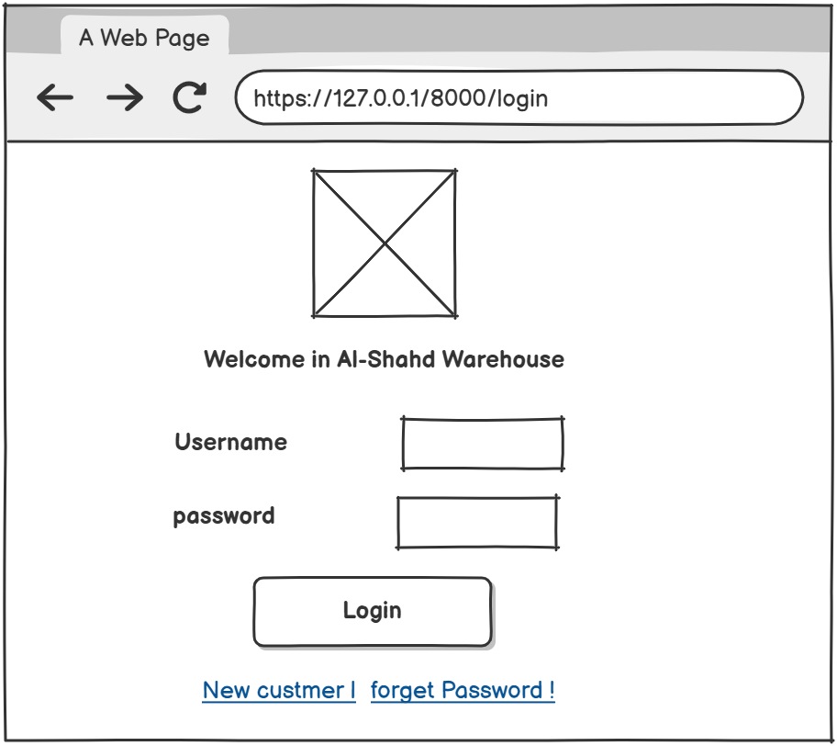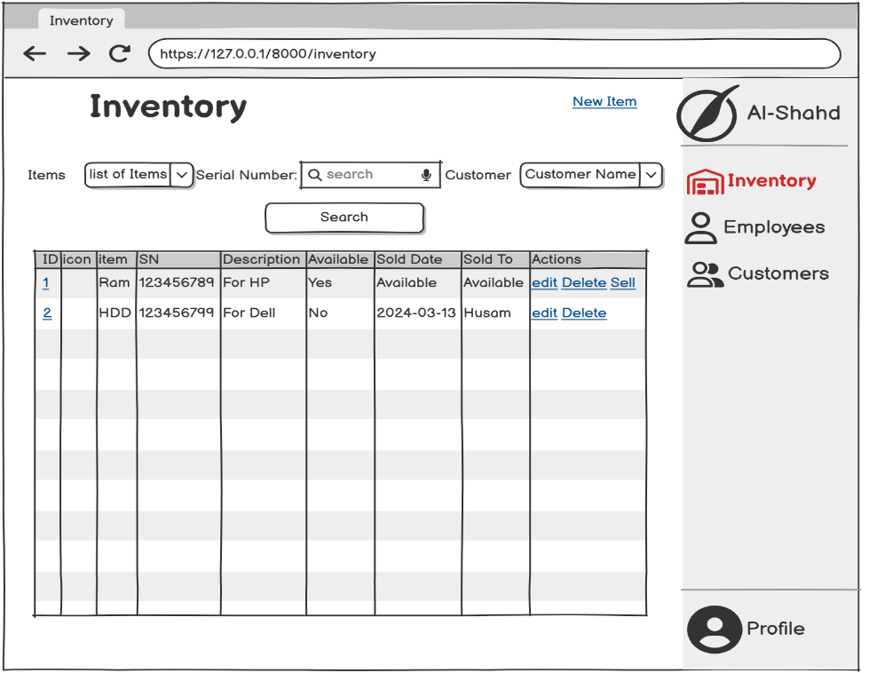**Wireframe**

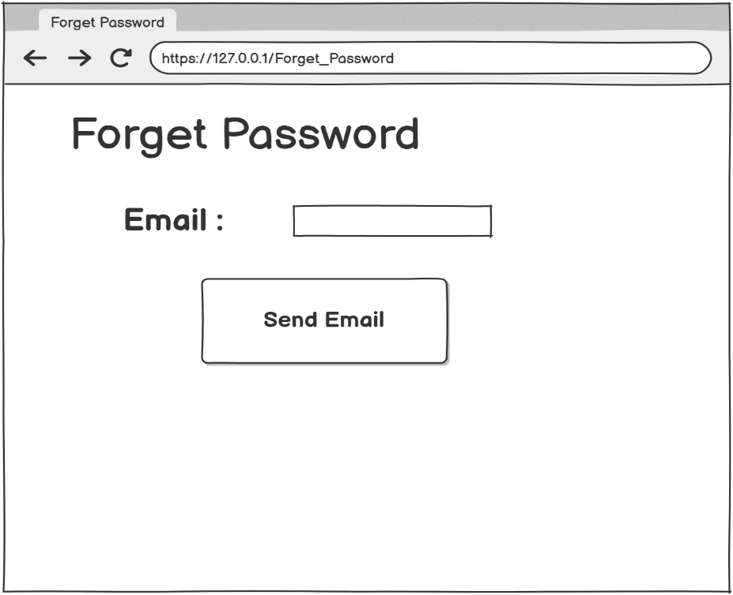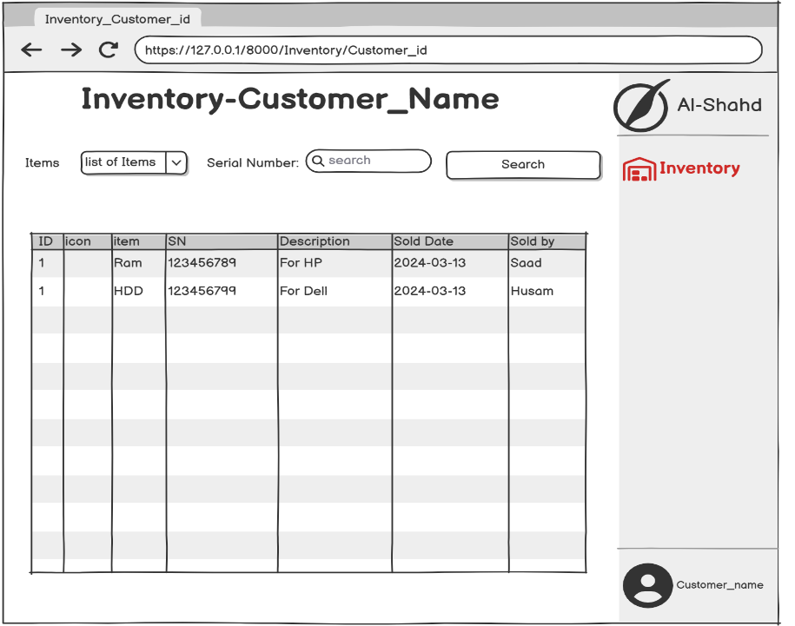 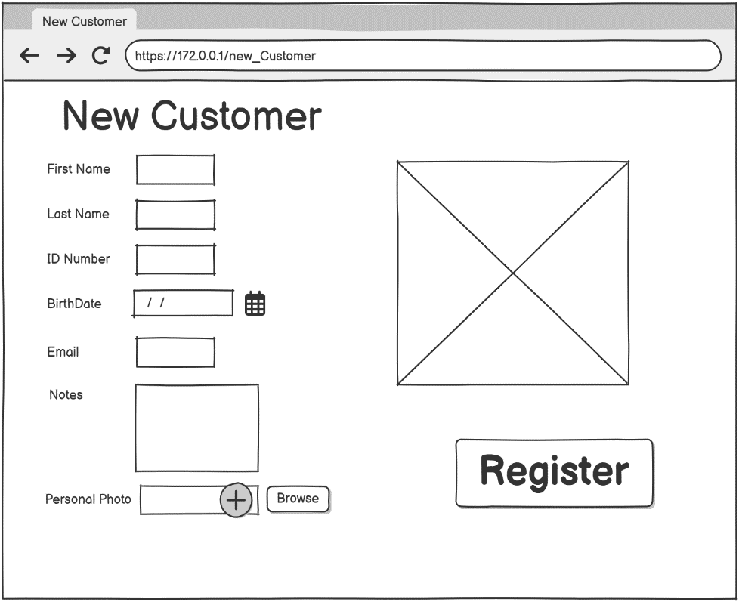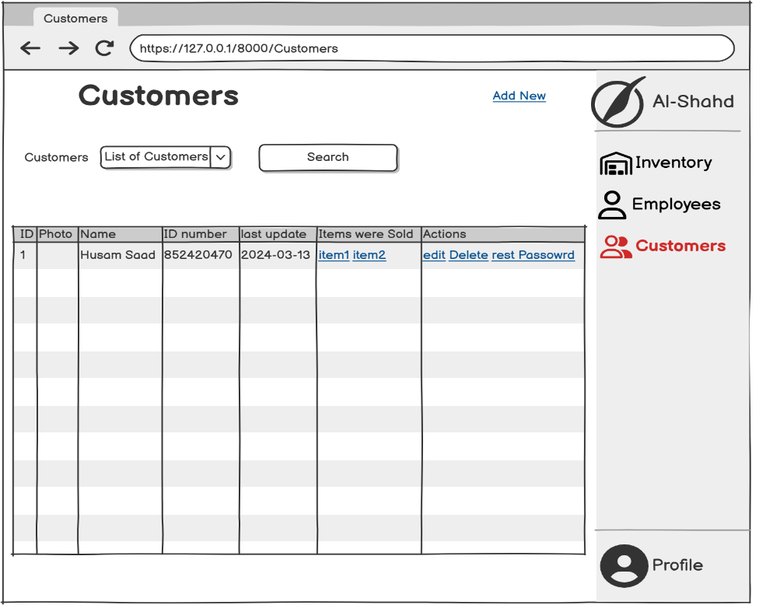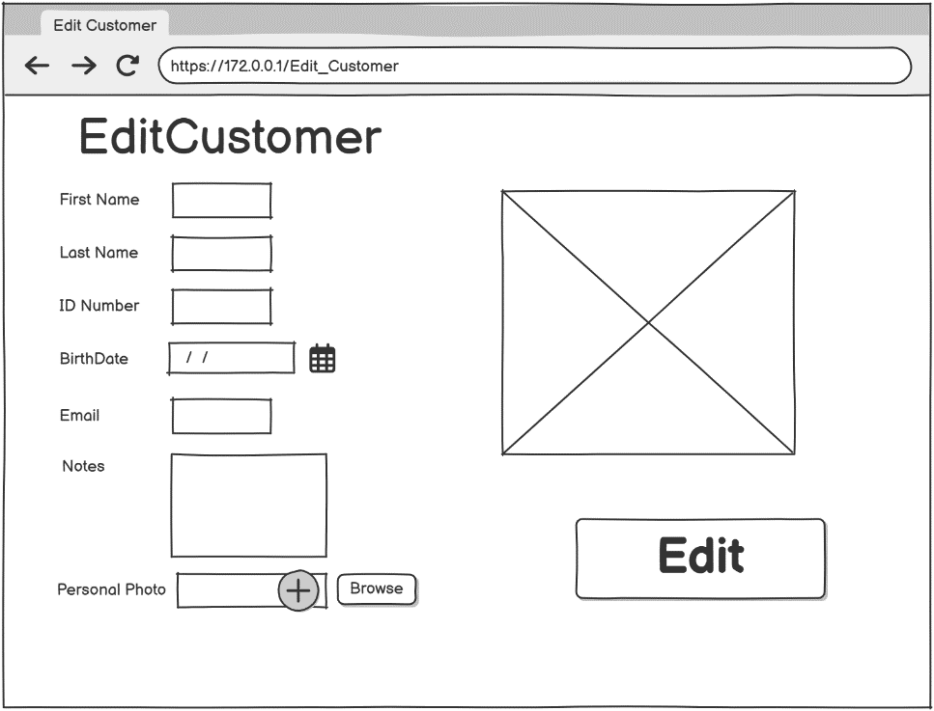

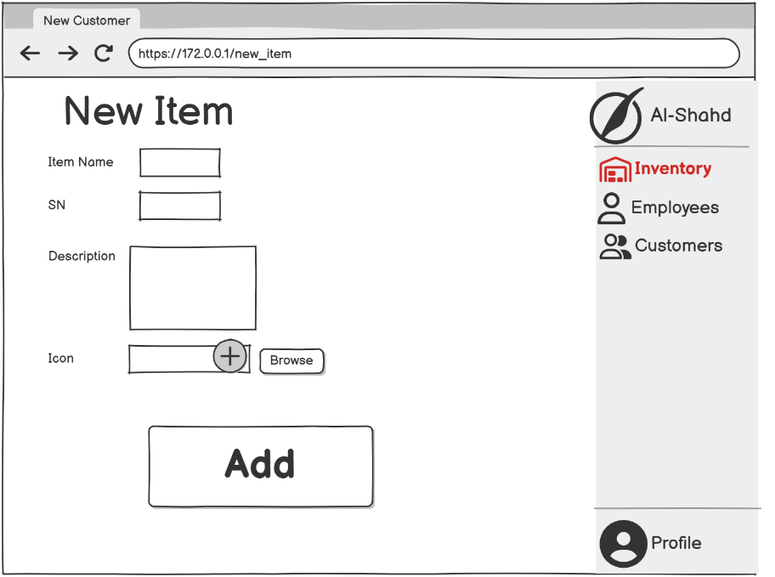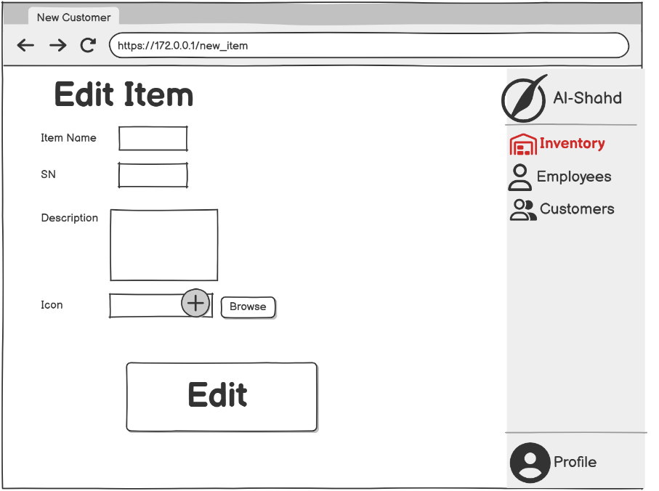

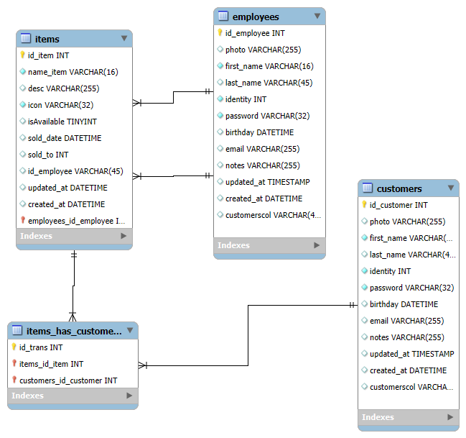

**GitHub Link:**

[**https://github.com/EngHusamSaad/Warehouse_Management.git**](https://github.com/EngHusamSaad/Warehouse_Management.git)

[**https://github.com/EngHusamSaad/Warehouse_Management**](https://github.com/EngHusamSaad/Warehouse_Management)

**Trello:**

**https://trello.com/b/ErdpcvaJ/warehousemanagement**